All members and visitors must comply with all Covid guidance and follow the below:
NHS Covid 19 Check in using the official NHS app – thank you.
Every person attending Darwen CC must sign in with the NHS app, anyone who doesn’t sign in will be refused entry and subsequent service. If you do not have a phone please give your details to bar staff. Please scan the QR code below or those at your table/around our club;
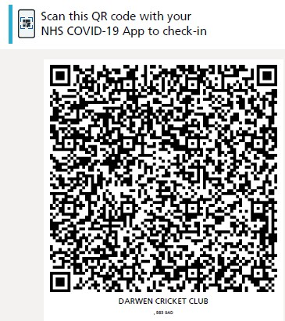

Darwen CC Food and Drink
Service by Darwen CC Bar staff will be outdoors only, at the picnic benches and boundary benches.
We have picnic benches near the clubhouse which will serve the normal bar, serving draught and all other normal drinks/deals. Food will be served at these tables also by the catering staff.
There is a “Darwen CC Boundary Bar” which will be serving cans & bottles for beer, lager, wine and spirits. These will only be served to people sat at benches and consumed sat down.
Alcohol that has not been purchased on the ground should not be consumed on the ground under any circumstances. DCC insist on this under the conditions of our license.

Covid 19 Hospitality Rules
You can only order Darwen CC food and drinks while seated. They must also be consumed while seated.
Anyone in the clubhouse, using the toilets, must wear a mask or face covering.
Please follow national guidance regarding social contact, which says maximum of either 6 people, or people from 2 households, can be in a group on our benches.
Please follow social distancing guidance.
Females will enter and use both toilets at the main entrance to the clubhouse. Male toilets will enter and use the toilets at the Peter Lamster Lounge end of our clubhouse. Please then follow the one-way system out and use hand sanitiser. All toilets are 1 in 1 out.
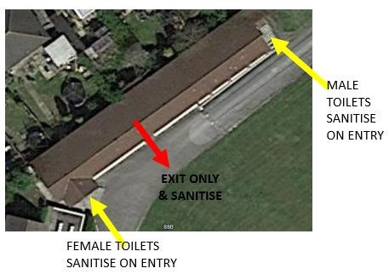
The players changing rooms are to only be used by Under 18’s for safeguarding purposes and as toilets – but only 1 in 1 out. Home and Away Captains are to enforce this.
Spectators are reminded not to touch the ball when it crosses the boundary.

Darwen CC Food and Drink ordering process
Please be patient and courteous to all Darwen CC staff and volunteers.
All staff are told to follow “Challenge 25” guidance.
Orders will only be taken at the tables and must be consumed at the tables seated.
You cannot order drinks without completing the NHS Track and Trace QR code.
Darwen CC bar staff and Catering staff will be visible around the Blackburn End Picnic tables so please get their attention for orders. There will also be a “Darwen CC Boundary Bar” serving the traditional benches around the ground. Again, please order with them when you get their attention and remain seated to order and consume.
We appreciate you following the above, respecting our club and its staff. As a club we are following the government and its rules and guidance to reduce the spread of Covid 19 and keep everyone safe.
Thank you for following the above, keeping everyone safe and supporting Darwen CC.
Darwen CC Executive & Commercial Committee
13/04/2021

